Comparative performance analysis of five ML techniques for classifying defects in steel sheets from images.

Md Abir Hasan

Bangladesh Army University of Science and Technology, Saidpur, Bangladesh

Abstract

We compared different types of models for identifying defects on steel sheets using images from high-frequency cameras. From this, we can get ideas about which model is better for detection, and this comparison is done using a trained ML and deep learning process. We focused on steel defect detection and aimed to mark pixel-wise defective areas. From previous work by other researchers, we have found that they researched image segmentation. We used Severstal steel images (a dataset). Russian Severstal Company Severstal mainly operates in the steel and mining industry. We found a CSV file that includes datasets and defects classified by segmentation. We took on a task to train and test those defects from those images and provided data using different types of methods. We explored five methods to solve the task. Two deep learning (CNN, Xception), one clustering (KNN), and two classification (SVM, Random Forest) methods.
By comparing their performances, we achieved the highest accuracy of 89.80% with the deep learning method Xception. Among those five methods, we can say Xception can give us the highest number of defect detection with fewer errors. We compared deep learning and machine learning outcomes in a single research project on steel defect detection.

1. Introduction

Steel is the most important engineering and construction material nowadays. It is used in every step of our lives. After materializing steel from elements, the production process of steel sheets is especially delicate. This process starts with heating steel, then rolling, drying, and cutting. Several machines touch flat steel by the time it’s ready to ship. Steel defects occur when those steel sheets are in the production process. Before providing these steel sheets outside the industry, they must undergo a careful inspection to avoid defects; thus, localizing and classifying surface defects is crucial. Hence, automating the inspection process would accelerate steel sheet production. By using deep learning and machine learning models with steel sheet images, we can detect those defects. This thesis is targeted at finding an efficient model for detecting defects on steel sheets with images from high-frequency cameras. The future goal is to ensure all industries provide defect-free steel sheets. Otherwise, items or other structures built of this steel might be put at risk.

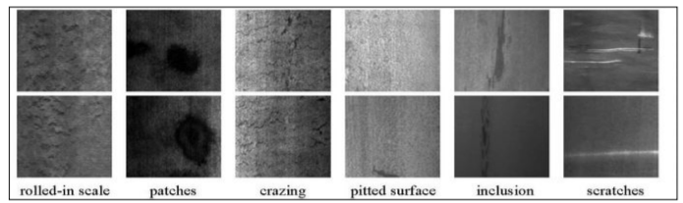
Figure 1.1: Several types of defects.

2. Related Works

For steel defect detection, we need the input, and that is an image of a steel sheet. For input, the output is a same-size segmented image with dense, defect-area marks. So the output is a pixel-wise label for the given input image, and it is an image processing segmentation task. Semantic and instance segmentation are two different sub-tasks. In the past, computer vision was not as powerful as in the present. So, it is a very hard task to segment objects from images. But after the invention of CNN, this problem of segmentation has turned into an easy task.

Semantic segmentation is considered a per-pixel classification problem. The popular CNN-based
The method of semantic segmentation is the Fully Convolutional Network (FCN) [1], which converts fully connected layers into 1x1 convolutional layers and achieves end-to-end per-pixel total prediction. FCNs for semantic segmentation can improve accuracy by transferring pre-trained classifier weights, combining different layer representations, and learning end-to-end on whole images. The traditional FCN method causes the problem of resolution loss. Two main methods are proposed to solve this problem. The first method [2] uses “atrous convolution," which enlarges the feature map with the help of linear interpolation. The second utilized deconvolution [10] to learn the upsampling process.
Compared to semantic segmentation, instance segmentation's goal is to predict class labels and also pixel-wise instance masks to localize varying numbers of instances presented in images. There are mainly two methods to solve instance segmentation problems: i) proposal-based methods and ii) segmentation-based methods. Proposal-based methods are related to object detection (Fast R-CNN, feature pyramid networks) [4, 5]. Mask R-CNN is a widely used method in this stream, which proposes to add a fully convolutional network branch based on (Feature pyramid networks) [5]. They achieve great performance on (Common objects in context, the cityscapes dataset for semantic urban scene understanding) [6, 7]. The other is segmentation-based methods, which use the output of semantic segmentation as input and gain instance-aware segmentation results later. Among them, (Monocular object instance segmentation and depth ordering with CNN and instance-level segmentation for autonomous driving with deep densely connected MRFs) [8, 9] proposed the use of a graphical model to guess the order of instances, and (Recurrent instance segmentation and Relay backpropagation for effective learning of deep convolutional neural networks) [10, 11] take advantage of RNNs to obtain one instance in each time step.

3. Dataset and Features
We used Severstal steel images (a dataset). The Russian Severstal company mainly operates in the steel and mining industry [12]. The company conducted a Kaggle competition by providing data on defective steel images. So basically, we collected data from Kaggle. The dataset we are using is one captured with high-frequency images of steel sheets that are shown in Figure 3.4. And the CSV file with features.

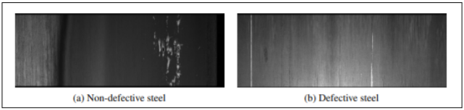
Figure 3.1: Examples of the defect and non-defect images in the SEVERSTAL dataset [12].

The images are 1600 × 256 × 1 in size, totaling 12568 images. 5902 images have defects, and 6666 images do not have defects out of all the images. There are four types of label defects: 1, 2, 3, and 4. A total of 897 images represent a class 1 defect, 247 images represent a class 2 defect, 5150 images represent a class 3 defect, and 801 images represent a class 4 defect. However, 6239 images have one defect class, 425 images have two defect classes, and only two images have three defect classes. And the important thing is we flatten all the images for use in this project. So there are a large number of features.
Due to memory space, we compute 3100 data points to get a result. In Figure 3.2, we can see a total of 393 images represent a class 1 defect, 107 images represent a class 2 defect, 2258 images represent a class 3 defect, and 341 images represent a class 4 defect.
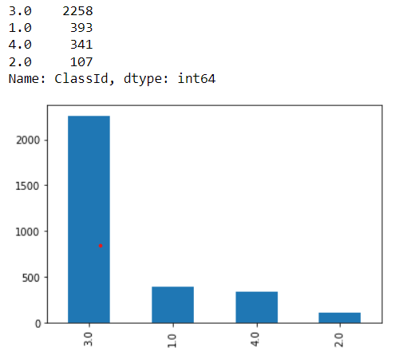
Figure 3.2: Count of defects with different classes.

4. Methodology

We suggested a total of five approaches for steel defect detection model creation and evaluation. The flowchart for the proposed methodology is given below:

4.1 Flow Chart
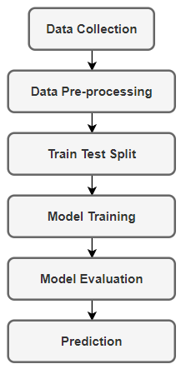
Figure 4.1.1: A basic overall methodology diagram for steel defect detection.

A flow chart for a deep learning and machine learning approach is given below:

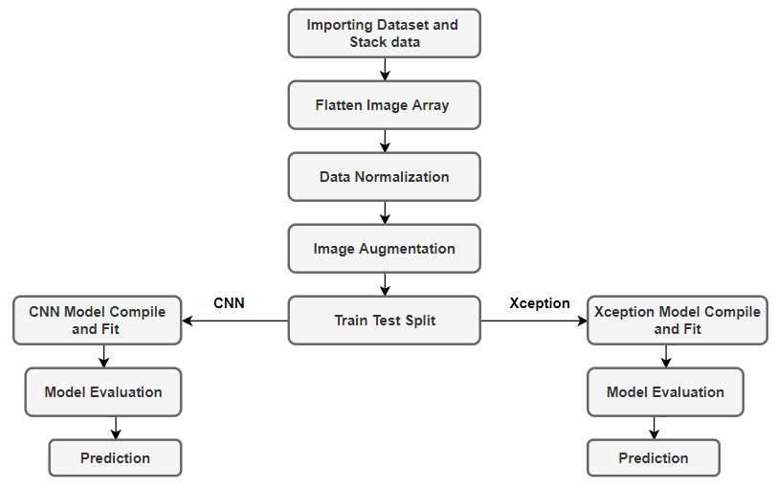
Figure 4.1.2: Diagram for deep learning methods.
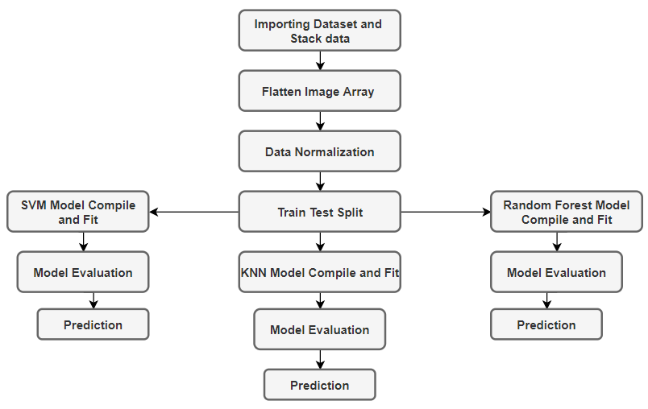
Figure 4.1.3: Diagram for machine learning methods.

5. Methods

We used both machine learning and deep learning methods to assess the accuracy of defect detection. A total of five methods are applied here. Two deep learning (CNN, Xception) and three machine learning techniques, including clustering (KNN) and classification (SVM, Random Forest) methods. Descriptions of these models and what we used in our work are given below:

5.1 Support Vector Machine (SVM)
The Support Vector Machine is part of the supervised learning algorithm. This model image is nicely categorized. In high-dimensional spaces, it works well. When the number of features is higher than the number of samples, it's critical to prevent over-fitting when selecting the kernel function and regularization term. We build two arrays after importing the dataset. One of them has a class and an image ID in it. The picture ID is then added to the stack. After flattening the picture array, normalize the data. We divided the dataset into train and test after normalization. For this SVM model, we'll utilize X_train, X_test, y_train, and y_test. We fit X and Y trains by importing the SVM class and setting the Radial Buffer Function (RBF) kernel. It's ready to compile. From Figure 3.8, we can get a visual idea of how SVM classifies data. The SVM method helps in the discovery of the optimal line or decision boundary, which is known as a hyperplane. The SVM method locates the closest point of the lines from both classes. Support vectors are the names given to these data points. Margin is the distance between the data points or vectors and the hyperplane. The purpose of SVM is to increase this margin as much as possible. The ideal hyperplane is the one with a long-range margin.

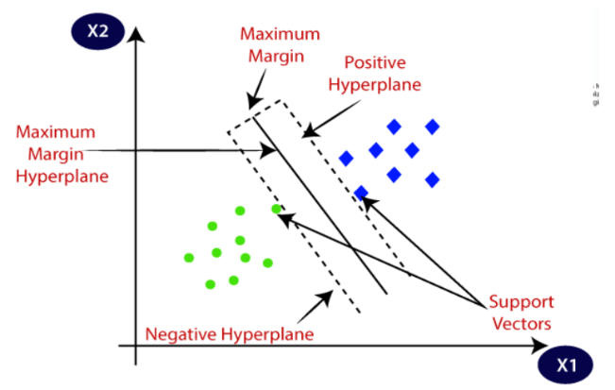
Figure 5.1.1: SVM Classifier

5.2 Random Forest
The Random Forest [19] is a well-known machine learning algorithm that uses the supervised learning method. In machine learning, it may be utilized for both classification and regression issues. It is based on ensemble learning, which is a method of integrating several classifiers to solve a complicated issue and increase the model's performance. We build two arrays after importing the dataset. One of them has a class and an image ID in it. The picture ID is then added to the stack. After flattening the picture array, normalize the data. We achieve our accuracy by importing the relevant library classes for this model and then using them. The structure of the random forest is shown in Figure 4.2.1.

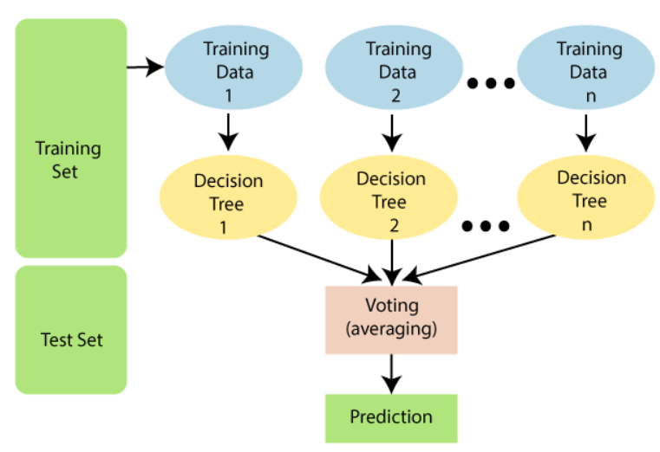
Figure 5.2.1: Random Forest Structure.

5.3 K-Nearest Neighbor (KNN)
K-Nearest Neighbors is one of the simplest machine learning algorithms based on the supervised learning technique. It assumes the similarity between the new case/data and available cases and puts the new case into the category that is most similar to the available categories. It stores all the available data and classifies a new data point based on its similarity. This means that when new data appears, it can be easily classified into a well-suited category by using this algorithm. K-Nearest Neighbor. After importing the dataset, we create two arrays. One of them contains a class and an image ID. Then we put the image ID on the stack. Flattening the image array then normalizes that data. After normalizing, we split the dataset into train and test. Now we use the X train, X test, and y train and y test for this KNN model. By importing the KNeighborClassifier class and setting the initial neighbor to 2. Then we fit the X train and Y train. Ready to compile. The main theme is to select k and calculate the distance from the k point to the category point. The closest distance of a category point is under that k point class.

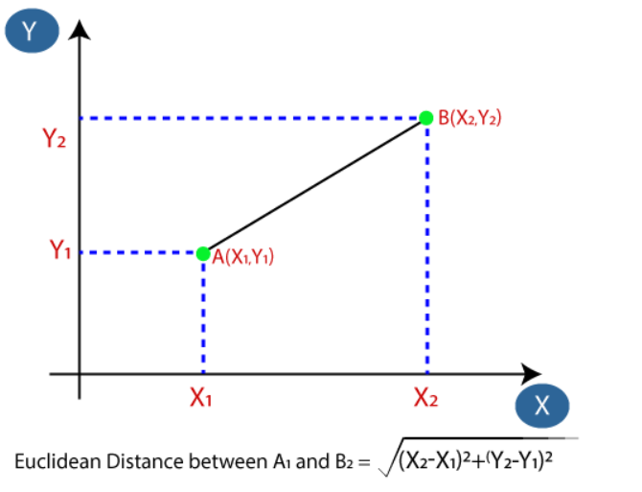
Figure 5.3.1: Distance Between 2 point

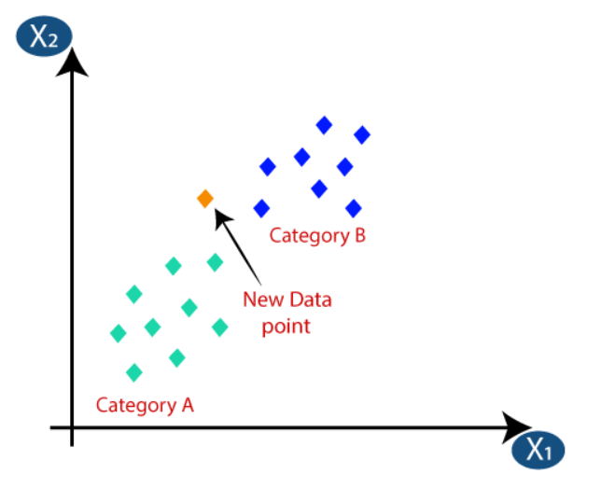
Figure 5.3.2: KNN classifier

5.4 Convolutional Neural Network (CNN)
The CNN [17] model is a type of neural network that allows us to extract higher representations for image data. Unlike traditional image recognition, which requires the user to define the image characteristics, CNN takes the image's raw pixel data, trains the model, and then extracts the features for improved classification. After importing the dataset, we create two arrays. One of them contains a class and an image ID. Then we put the image ID on the stack. Flattening image arrays then normalizes that data. Importing necessary library classes, we check the dataset shape. We did image argumentation. Here we resize those images into 120x120 and put that with the classid in a different array. Encode the classid array using a label encoder. Then, split the train and test data. Then make a model and compile it. Convolution layers, pooling layers, and fully connected layers are among the building components of the CNN architecture. A typical design comprises one or more completely linked layers followed by a stack of many convolution layers and a pooling layer.
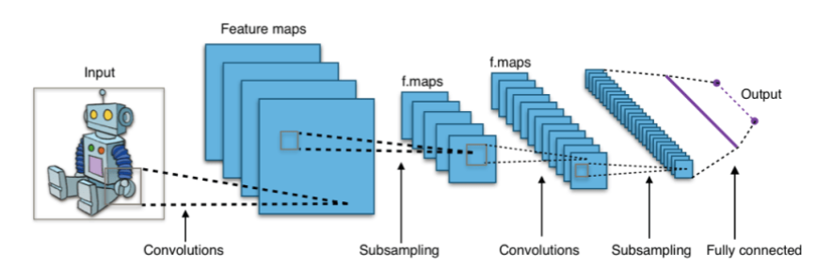
Figure 5.4.1: CNN Architecture.

5.5 Xception
Xception [13] is a depthwise separable convolutions-based deep convolutional neural network architecture developed by Google Corporation. The "extreme" form of an Inception module is known as Xception. In Inception, 1x1 convolutions were used to compress the original input, and different types of filters were applied to each of the depth spaces based on the input spaces. Xception just reverses this process. Instead, it applies the filters to each depth map individually before compressing the input space using a 1X1 convolution across the depth. This approach is nearly equivalent to a depthwise separable convolution. One further difference exists between Inception and Xception. After the initial operation, the existence or absence of a nonlinearity. Both processes are followed by a ReLU non-linearity in the Inception model; however, Xception does not add any non-linearity. In Figure 3.7, the overall Xception architecture is shown. The data initially passes via the entering flow, then eight times through the middle flow, and lastly through the exit flow. Batch normalization is applied to all convolution and separable convolution layers (not shown in the picture). A depth multiplier of 1 (no depth expansion) is used in all separable convolution layers. We did image argumentation. Here we resize those images into 120x120 and put that with the classid in a different array. Encode the classid array using a label encoder. Then, split the train and test data. Then make a model and compile it. GlobalAveragePooling2D, BatchNormalization, and fully linked layers are among the building components of the CNN architecture.

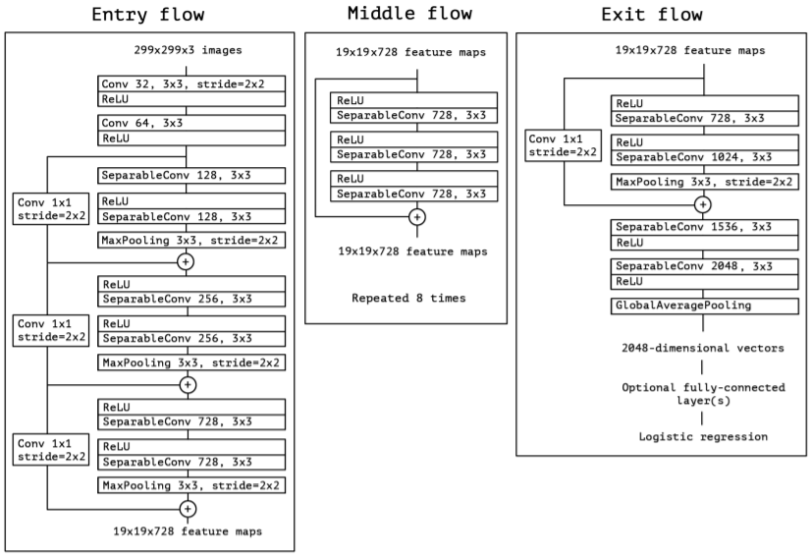
Figure 5.5.1: Overall Xcption Architecture

6. Experimental Result

6.1 Classification Reports of Machine Learning Approaches

Support Vector Machine (SVM):
The confusion matrix and classification report for this are given below:

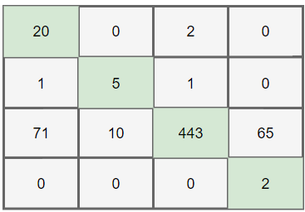

Figure 6.1.1: SVM Confusion Matrix.

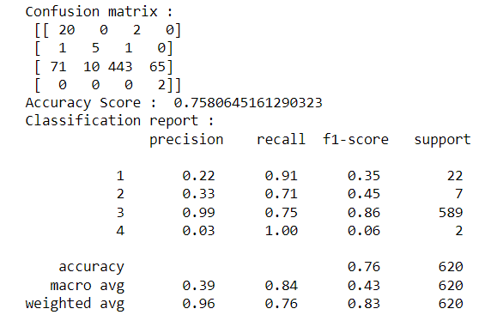

Figure 6.1.2: Classification Result of SVM.

Finally, we got 75.80% detection accuracy using the support vector machine.

Random Forest:
The confusion matrix and classification report for this are given below:

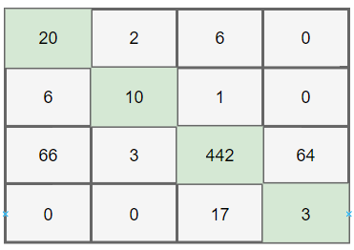

Figure 6.1.3: Random Forest Confusion Matrix.

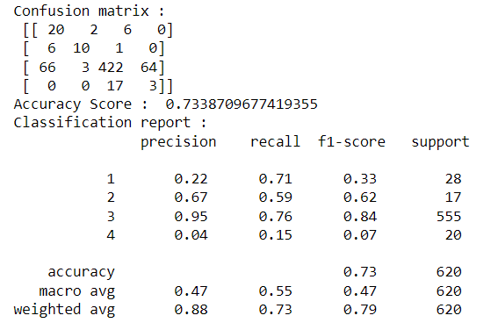

Figure 6.1.4: Classification Result of Random Forest.

Finally, we got 73.38% detection accuracy using a random forest classifier.

K-Nearest Neighbor (KNN):
The confusion matrix and classification report for this are given below:

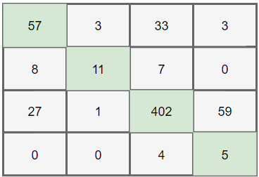

Figure 6.1.5: KNN Confusion Matrix.

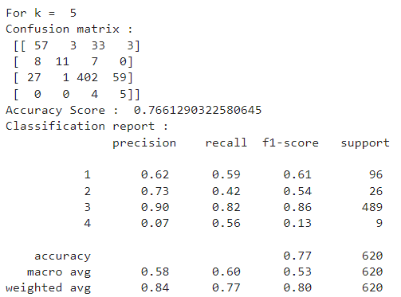

Figure 6.1.6: Classification Result of KNN.

Finally, we got 76.61% detection accuracy using the support vector machine.

6.2 Reports of Deep Learning Approaches

Convolutional Neural Network (CNN):
By setting up batch size 128 and epochs 15, we evaluate the CNN model. This model gives us 75.81% detection accuracy. This model’s accuracy and loss curves are given below:

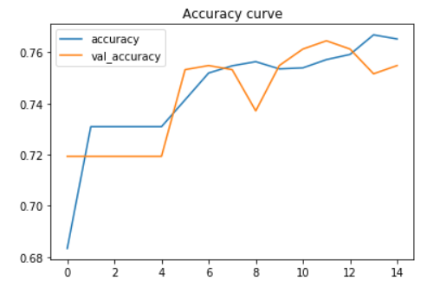
Figure 6.2.1: CNN Accuracy Graph

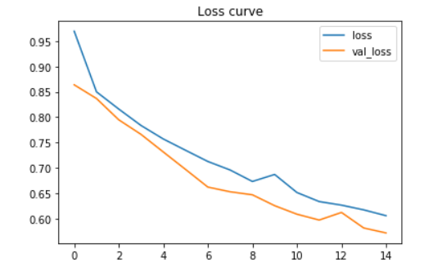
Figure 6.2.2: CNN Loss Graph

Xception:
By setting batch size to 128 and epochs to 30, we evaluate the Xcption model. This model gives us 89.80% defect detection accuracy. This model’s accuracy and loss curves are given below:

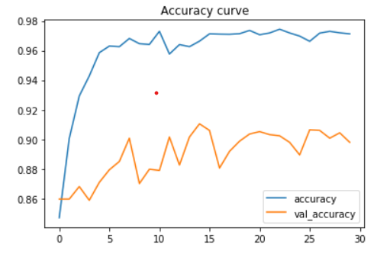
Figure 6.2.3: Xception Accuracy Graph

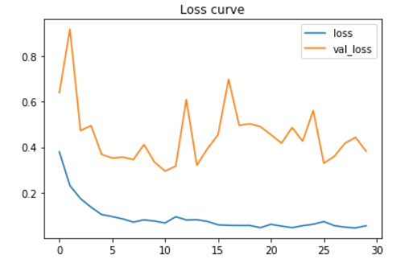
Figure 6.2.4: Xception Loss Graph

6.3 Comparison Table
Model comparison table:

 | No | Model | Accuracy(%)
Machine Learning | 1 | Random Forest | 73.38
 | 2 | Support Vector Machine | 75.80
 | 3 | K-Nearest Neighbor | 76.61
Deep Learning | 4 | Convolutional Neural Network | 75.81
 | 5 | Xception | 89.80

7. Future Plan

On the rare defect classes, further data augmentation techniques, such as rotation and scaling on the images, should be done due to the imbalance between different kinds of labels. Measure accuracy without resizing the image. To see what the difference in accuracy is, we need to test accuracy without altering the size. Different image sizes are used to test accuracy. It's possible that increasing the size of the image will improve the accuracy of detecting defects. That is something we must investigate. It is possible to generate more accurate results by combining different models in a single system. This is something more that has to be looked at.

8. Conclusion

The goal of this thesis is to compare different types of models for identifying defects on steel sheets using images from high-frequency cameras. From this, we can get ideas about which model is better to use for better detection. The long-term objective is to guarantee that all industries can supply defect-free steel sheets. Otherwise, items or other structures built of this steel might be put at risk. To complete the objective, we looked at five different approaches. There are two deep learning methods (CNN and Xception), one clustering method (KNN), and two classification methods (SVM and Random Forest). In a single study of steel defect identification, we attempted to demonstrate the contrast between deep learning and machine learning outcomes. In terms of detection accuracy, KNN exceeds the other two machine learning algorithms by 76.61 percent. In the deep learning model, Xception exceeds CNN with an accuracy of 89.80%. As a result, among those five methods, Xception can give us the highest number of defect detections with fewer errors, and we can state that deep learning approaches are a superior alternative for detecting steel defects.

9. References

- J. Long, E. Shelhamer, and T. Darrell. Fully convolutional networks for semantic segmentation. In Proceedings of the IEEE Conference on Computer Vision and Pattern Recognition, pages 3431–3440, 2015.
- L.-C. Chen, G. Papandreou, I. Kokkinos, K. Murphy, and A. L. Yuille. Deeplab: Semantic image segmentation with deep convolutional nets, atrous convolution, and fully connected CRFs. IEEE transactions on pattern analysis and machine intelligence, 40(4):834–848, 2017
- H. Noh, S. Hong, and B. Han. Learning a deconvolution network for semantic segmentation. In Proceedings of the IEEE International Conference on Computer Vision, pages 1520–1528, 2015
- R. Girshick. Fast R-CNN. In Proceedings of the IEEE International Conference on Computer Vision, pages 1440–1448, 2015
- T.-Y. Lin, P. Dollar, R. Girshick, K. He, B. Hariharan, and S. Belongie. Feature pyramid networks for object detection. In Proceedings of the IEEE conference on computer vision and pattern recognition, pages 2117–2125, 2017
- T.-Y. Lin, M. Maire, S. Belongie, J. Hays, P. Perona, D. Ramanan, P. Dollar, and C. L. Zitnick. Microsoft Coco: Common objects in context. In the European Conference on Computer Vision, pages 740–755. Springer, 2014.
- M. Cordts, M. Omran, S. Ramos, T. Rehfeld, M. Enzweiler, R. Benenson, U. Franke, S. Roth, und B. Schiele. The cityscapes dataset for semantic urban scene understanding. In Proceedings of the IEEE Conference on Computer Vision and Pattern Recognition, pages 3213–3223, 2016.
- Z. Zhang, A. G. Schwing, S. Fidler, and R. Urtasun. Monocular object instance segmentation and depth ordering with CNN. In Proceedings of the IEEE International Conference on Computer Vision, pages 2614–2622, 2015
- Z. Zhang, S. Fidler, and R. Urtasun. Instance-level segmentation for autonomous driving with deep, densely connected MRFs. In Proceedings of the IEEE Conference on Computer Vision and Pattern Recognition, pages 669–677, 2016.
- B. Romera-Paredes and P. H. S. Torr. Recurrent instance segmentation. In the European Conference on Computer Vision, pages 312–329. Springer, 2016.
- L. Shen, Z. Lin, and Q. Huang. Relay backpropagation for effective learning of deep convolutional neural networks. In the European Conference on Computer Vision, pages 467–482. Springer, 2016.
- Severstal: Steel Defect Detection
- F. Chollet. Xception: Deep learning with depth-wise separable convolutions. In Proceedings of the IEEE Conference on Computer Vision and Pattern Recognition, pages 1251–1258, 2017.
- Weidong Zhao, Feng Chen, Hancheng Huang, Dan Li, and Wei Cheng, "A New Steel Defect Detection Algorithm Based on Deep Learning," Computational Intelligence and Neuroscience, vol. 2021, Article ID 5592878, 13 pages, 2021.
- Qianlai Sun (孙前来), Yin Wang (王银), and Zhiyi Sun (孙志毅), "Rapid surface defect detection based on singular value decomposition using steel strips as an example," AIP Advances 8, 055209 (2018).
- Kun Qian, “Automated Detection of Steel Defects via Machine Learning based on Real-Time Semantic Segmentation” ICVIP 2019: Proceedings of the 3rd International Conference on Video and Image Processing, Pages 42–46, December 2019.
- Matthew Browne, Saeed Shiry Ghidary, “Convolutional Neural Networks for Image Processing: An Application in Robot Vision," Australasian Joint Conference on Artificial Intelligence AI 2003: Advances in Artificial Intelligence pp 641-652.
- Zhu Fan, Jia-Kun Xie, Zhong-yu Wang, Pei-Chen Liu, “ Image Classification Method Based on Improved KNN Algorithm," J. Phys.: Conf. Ser. 1930, 2021 International Conference on Sensing Technology and Applications (ICSTA 2021), 23-25 April 202
- Baoxun Xu, Yunming Ye, and Lei Nie, “An improved random forest classifier for image classification," In Proceedings of the 2012 IEEE International Conference on Information and Automation, 6-8 June 2012.

